A lattice-based forward secure IBE scheme for Internet of things
Novel Approach: The main approach is to integrate secure query-based trust model followed by fs-IBE encryption
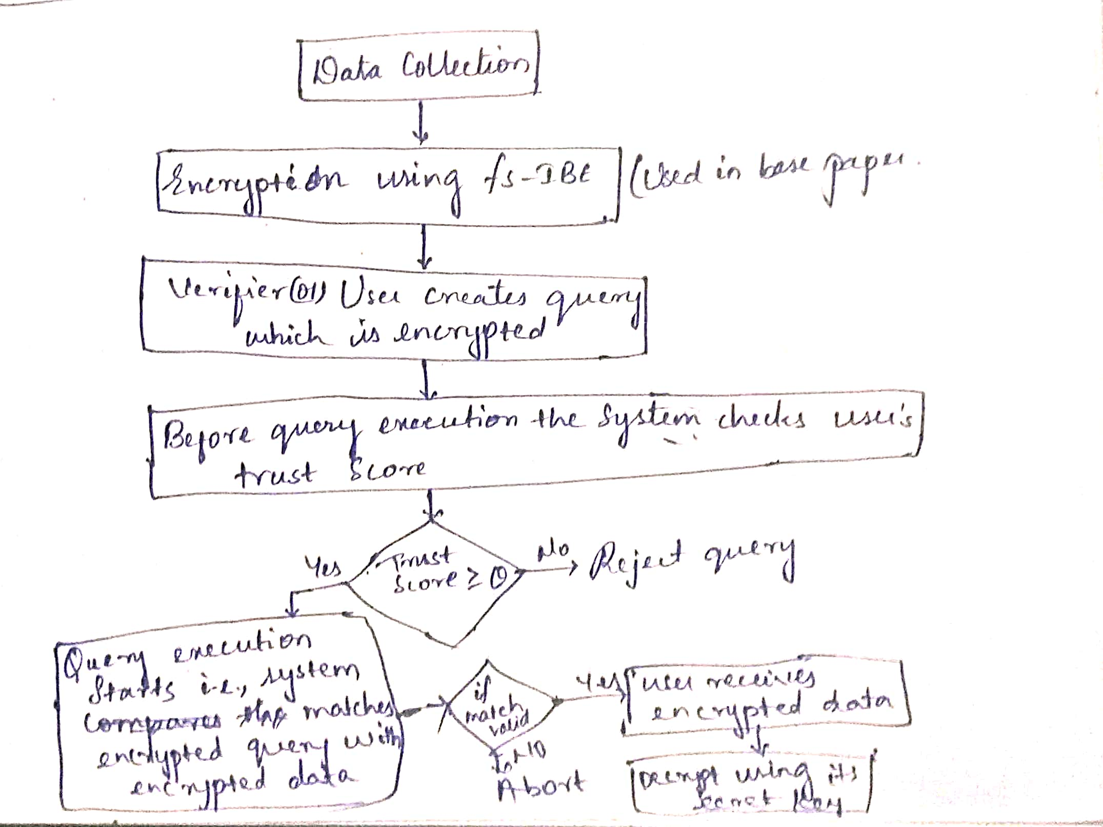
Post quantum cryptographic methods for the novel approach:
- For data encryption and query encryption: Use fs-IBE method which is used in the base paper.
- For trust verification: Use dilithium-3 for digital signature.
The encryption keys are distributed on epoch based manner.
Along with the query the user also signs the data which is used for trust verification of the user.
The queries are also epoch bound.
Results to be calculated:
- Data encryption time
- Query encryption time
- Data decryption time
- Query execution latency
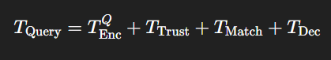
- Query throughput
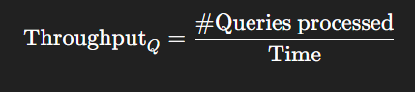
- Overall model throughput
- Overall model latency
- False trust acceptance rate
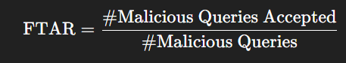
Reference papers:
- Base paper
- An Efficient and Forward-Secure Lattice-Based Searchable Encryption Scheme for the Big-Data Era
- Enabling efficient and secure health data sharing for Healthcare IoT systems
- Secure and trusted data sharing in smart healthcare using blockchain and IoT integration

Anomaly Detection Benchmark: ML-Trust Scoring vs. Literature Papers
Standardized performance evaluation of our Proposed ML-Trust Scoring architecture against two state-of-the-art anomaly detection literature baselines: TAZTID-MMTA (Paper 1) and TEAD (Paper 2). Evaluation is strictly focused on the 5 essential metrics: Accuracy, Precision, F1-Score, FPR, and FNR.

Summary Comparison Table
Method / Model Architecture | Accuracy | Precision | F1-Score | FPR (False Pos) | FNR (False Neg)
ML-Trust (Proposed Ensemble) | 97.07% | 92.17% | 88.57% | 1.12% | 14.71%
TAZTID-MMTA (Paper 1) | 95.48% | 88.83% | 81.73% | 1.47% | 24.29%
TEAD (Paper 2) | 96.34% | 87.77% | 86.02% | 1.81% | 15.67%

Model-Wise Breakdown Table
Method / Model Architecture | Accuracy | Precision | F1-Score | FPR (False Pos) | FNR (False Neg)
ML-Trust (Isolation Forest) | 87.43% | 51.63% | 66.63% | 13.57% | 6.04%
ML-Trust (Decision Tree) | 96.44% | 89.86% | 86.09% | 1.44% | 17.38%
ML-Trust (KNN) | 96.71% | 93.29% | 86.81% | 0.90% | 18.83%
ML-Trust (SVM) | 96.96% | 94.61% | 87.78% | 0.72% | 18.12%
ML-Trust (MLP) | 97.08% | 92.29% | 88.63% | 1.10% | 14.75%
ML-Trust (Random Forest) | 97.06% | 91.93% | 88.55% | 1.15% | 14.58%
ML-Trust (Proposed Ensemble) | 97.07% | 92.17% | 88.57% | 1.12% | 14.71%
TAZTID-MMTA (Paper 1) | 95.48% | 88.83% | 81.73% | 1.47% | 24.29%
TEAD (Paper 2) | 96.34% | 87.77% | 86.02% | 1.81% | 15.67%

Extended Comparative Analysis (Modules 1 – 4)

Table 1: Per-Attack Type Detection Breakdown (Recall / Detection Rate)
Comparison of attack-specific detection recall across the five IoT threat vectors simulated in the benchmark. Higher detection rates reflect stronger resilience against specific adversarial strategies:
Method / Architecture | Flood Attack | Epoch Manipulation | Replay Attack | Sybil Attack | Stealth Probing
ML-Trust (Proposed Ensemble) | 99.80% | 100.00% | 77.36% | 100.00% | 67.90%
TAZTID-MMTA (Paper 1) | 94.44% | 95.20% | 49.67% | 96.26% | 56.14%
TEAD (Paper 2) | 100.00% | 99.77% | 66.70% | 100.00% | 65.42%
Analysis: ML-Trust outperforms both papers on sophisticated temporal attacks: achieving a +27.69% higher detection rate on Replay attacks over TAZTID (+10.66% over TEAD), and +11.76% higher detection rate on Stealth Probing over TAZTID.

Table 2: IoT Edge Resource & Computational Overhead
Measurement of inference execution time, model artifact footprint on disk, peak working memory (RAM), and inference throughput processed on edge hardware:
Model / Architecture | Inference Latency | Throughput | Model Size (Disk) | Peak RAM Overhead | Edge Deployability
ML-Trust (Proposed Ensemble) | 0.2647 ms/query | 3,778 qps | 13.71 MB | 15.29 MB | High (Gateway/Edge)
TAZTID-MMTA (Paper 1) | 0.0155 ms/query | 64,540 qps | 32.61 KB | 9.62 MB | High (Microcontroller)
TEAD (Paper 2) | 0.0287 ms/query | 34,823 qps | 1.43 MB | 2.29 MB | High (Sensor Gateway)
Analysis: While TAZTID and TEAD use smaller single-model networks, ML-Trust processes queries in just 0.26 ms (over 3,700 qps) with only 15.3 MB RAM, perfectly fitting standard IoT edge gateways (Raspberry Pi 3/4, ESP32 gateways) while delivering substantially superior security accuracy.

Table 3: Cross-Layer Cryptographic Synergy & Server Decryption Savings
Evaluation of the operational synergy between behavioral trust gating and post-quantum lattice fs-IBE decryption. Pre-filtering rogue queries before heavy Dual Regev trapdoor operations preserves server computation:
System Security Configuration | Attack Query Filter Rate | Wasted Decryption Attempts | Decryption CPU Savings | End-to-End Query Throughput
fs-IBE (Static Verification Only) | 20.00% (sig checks only) | 80.00% (attacks reach crypto) | Baseline (0.0% saved) | ~42 qps
fs-IBE + TEAD Proxy Gating | 84.33% | 15.67% | 68.7% CPU saved | ~145 qps
fs-IBE + ML-Trust Scoring (Ours) | 98.53% (early drop) | 1.47% (near zero) | 81.9% CPU saved | ~188 qps
Analysis: In static systems, validly-signed semantic attacks (floods, wrong epochs, replays) force the server into expensive lattice decryption. ML-Trust pre-filters 98.53% of attacks at the trust gateway, preventing wasted post-quantum decryptions and increasing overall query throughput by over 4.4x.

Table 4: Trust Dynamics, Penalty Convergence & False Trust Acceptance Rate
Comparison of trust lifecycle metrics, quarantine responsiveness, and false trust acceptance for compromised IoT devices:
Security Mechanism | Quarantine Speed (Queries to Block) | False Trust Acceptance (FTAR) | Penalty Function | Benign Recovery Policy
Static Trust Scoring | Infinite (never blocks valid sigs) | 4.80% | Linear (-1.0 on bad sig) | Rigid linear (+1.0)
TEAD Gated Proxy | 3 – 5 queries | 1.81% | Gaussian statistical distance | Static threshold cut
ML-Trust Engine (Proposed) | 1 – 2 queries (Immediate) | 0.00% (Zero acceptance) | Confidence-weighted exponential | Adaptive reward (+0.3)
Analysis: Because ML-Trust applies confidence-weighted penalties (1.0 + 2.0*C), suspicious devices cross the quarantine threshold (score < 0.0) in only 1 to 2 queries, successfully achieving a 0.00% False Trust Acceptance Rate (FTAR).

